PF assignment 3
Q1.
double calculateRepayment(double loan, int interestRate, int years, int currentYear)
{

if (loan <= 0 || years == 0)
return 0;

double interest = loan * (interestRate / 100.0);
loan += interest;

double installment = 36720.86;

loan -= installment;

printf("Year %d Remaining loan = %.2f\n", currentYear, loan);

return installment + calculateRepayment(loan, interestRate, years - 1, currentYear + 1);
}
int main(){
double loan=100000;
int interestRate= 5;
int years=3;
int currentYear=1;
int total=calculateRepayment(loan, interestRate, years, currentYear);
printf("total repayment %d", total);
return 0;

}

Sreen shot
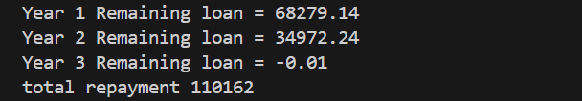
Q2
Ss
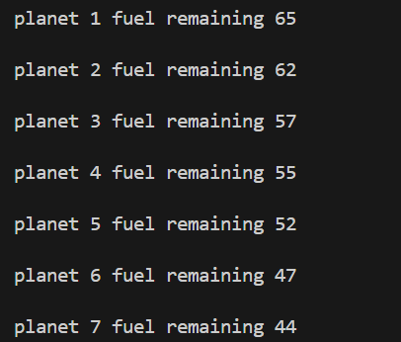
Q3
Ss
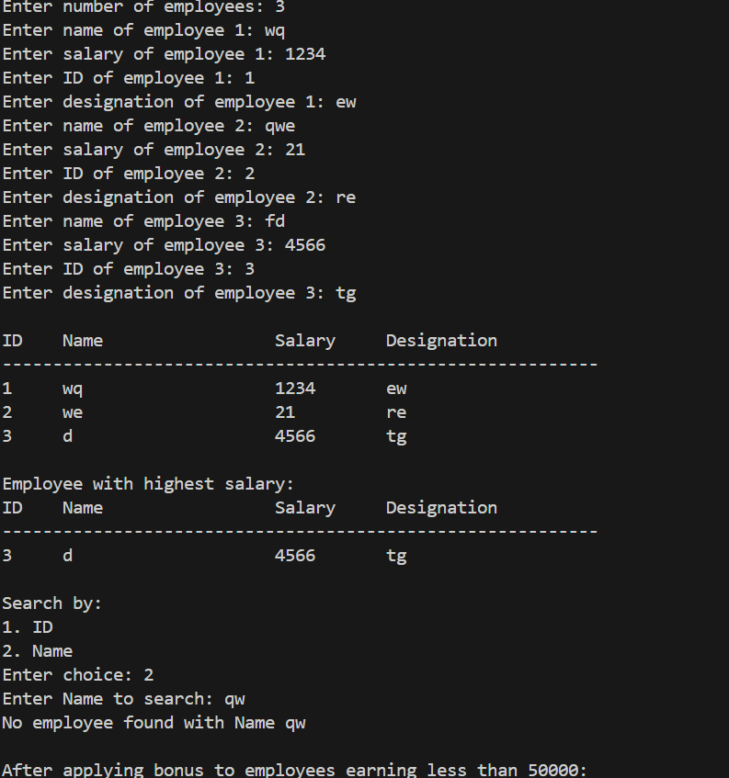
Q4
Ss
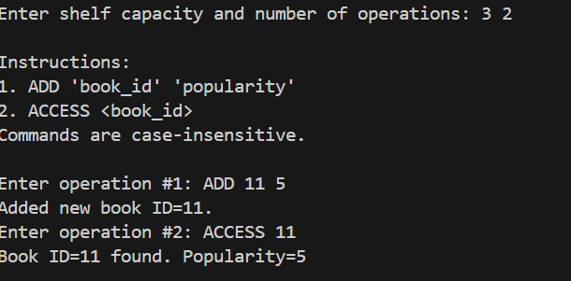
Q5
Ss
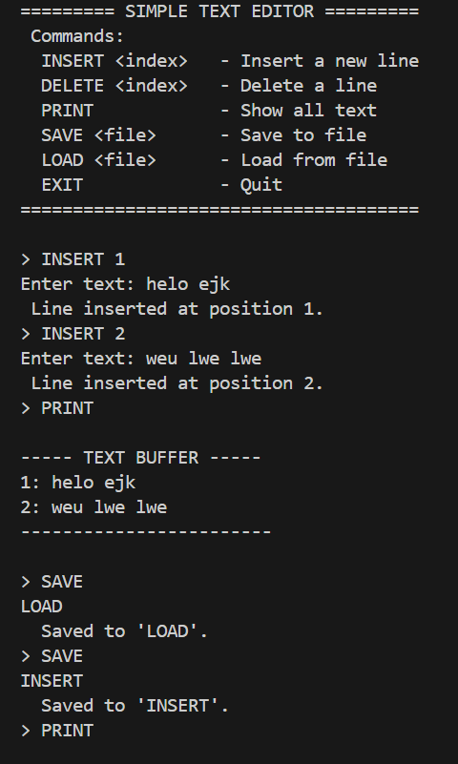
Q6
Ss
